**REPORT ON DELIVERABLES**

1. Main account in the dashboard is still name as main account with the same position and extra wallet still named as extra account in the same position.

CORRECTION: the first card which is name as main account should be renamed as extra wallet and be taken to the position of card 2 while the extra wallet should be named as main account and be taken to position 1. The same error should be fixed in the activity page.

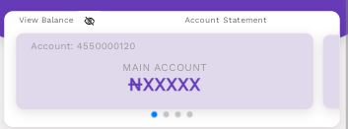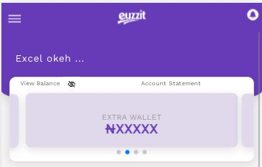

Main Wallet

Extra wallet

Card 2

Card1

Take card1 to card2 position and card2 to card1 position.

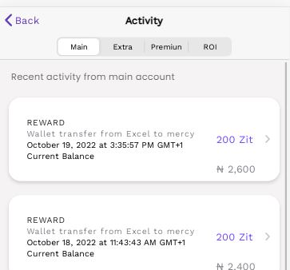

The same correction is applied to account activity.

When sending money or making purchase. After choosing the account. We observed that the account type is not having the same narration. When you select main account, what will display as been selected will be extra account text.

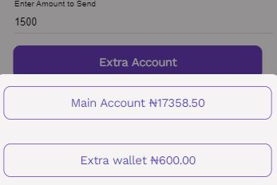

Zit ranking page

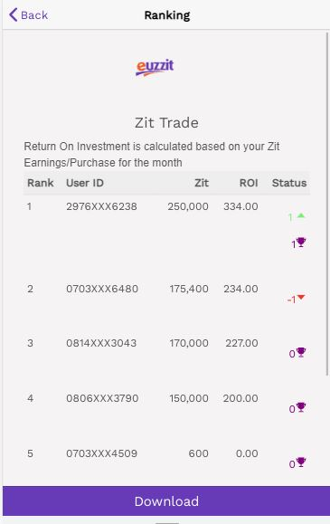

Remove

Make this area and above to be fixed

Adjust images to align with the records

From the table head and above should be fixed

1. a. Send to wallet does not provide response(success)

b. send to bank (euzzit) does not provide response(success)

4. This is OK

5. this is OK

6. This is ok.

7. name should be re-captioned as business name, location should be the merchant address, No back button

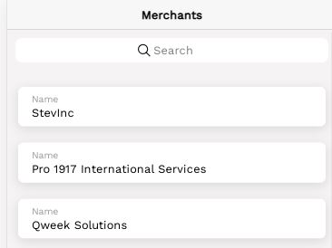

No back button

Business Name

Location: merchant address

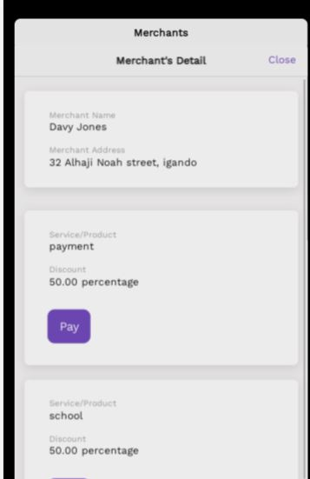

This card should be colourd in purple

8. this is ok

9. I will need to show you the error on google online meeting for better understanding

10. account statement is not clickable and view balance also

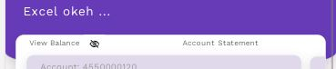

HOME SCREEN

On the home screen let the spacing between each rows of features and any other items be reduced so that the whole element in the home screen can be seen in one view.

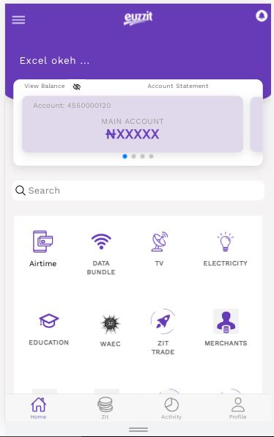

Reduce spacing

Reduce spacing